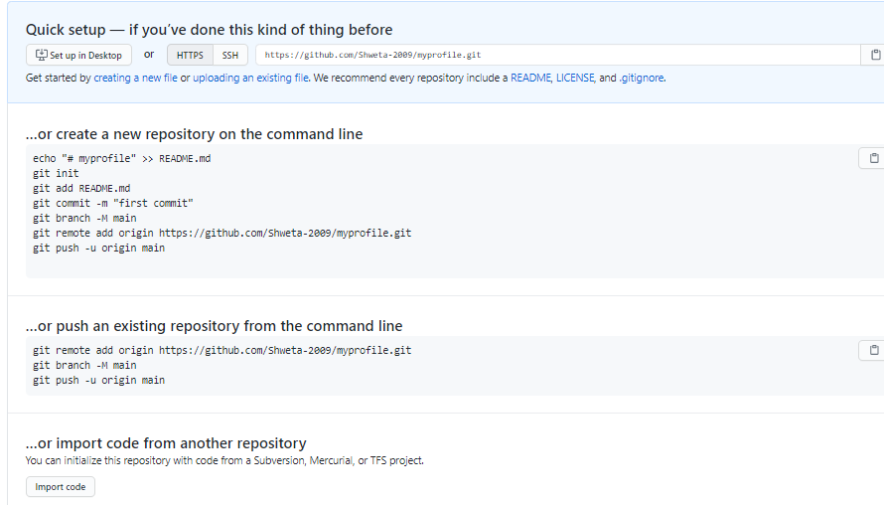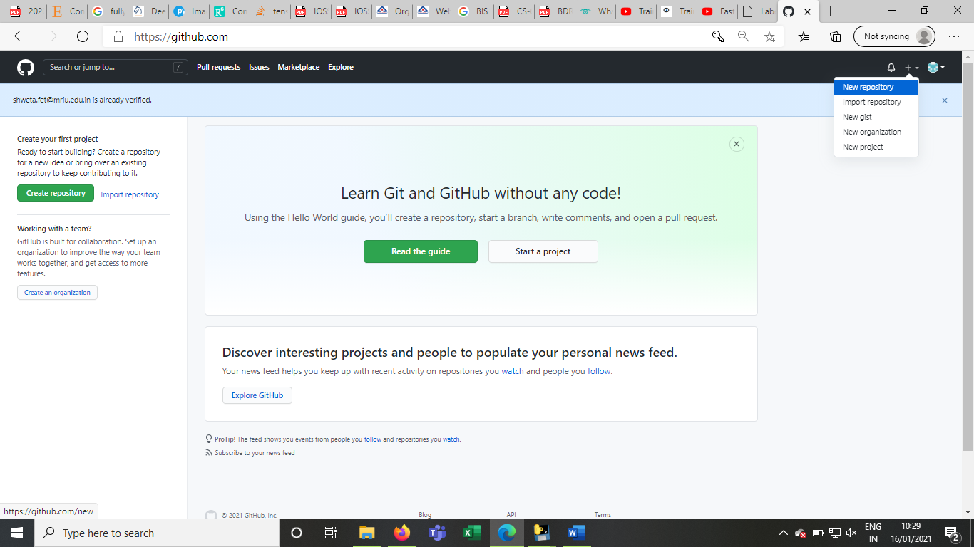

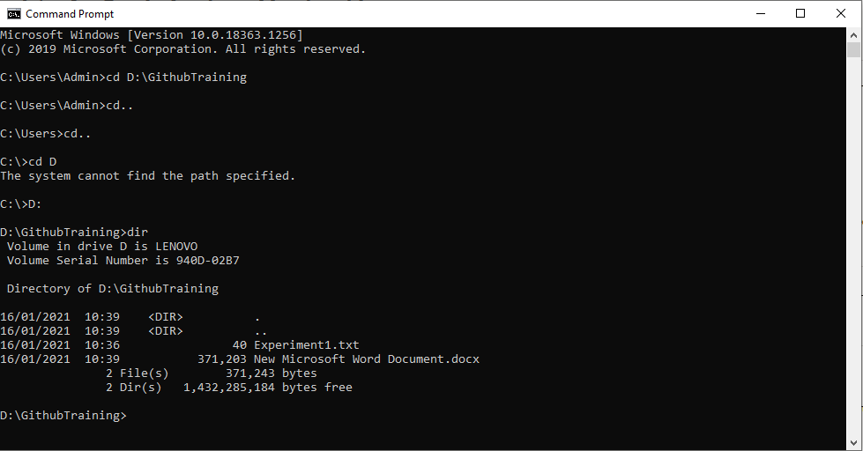



1.Local repository- myprofile

2.Staging area- intermediate to check for the final commit

3.Github repository- init created the .git hub

Local repository to staging area and then pushed to the git hub repository



First commit can be shown in the nnetwork graph has the importance.Try to write in the present tense”

-m : m flag used for commiting

The file goes from the locaal repository is sent to the staging area by the above commit command.

As there is no file which to commit so then we can add the files using the following file